# Guide to Setting up the Optimal Development Environment

# Install JDK

1. Download latest stable Java SE 7 from here:

[http://www. oracle.com/technetwork/java/javase/downloads/index.html](http://www.oracle.com/technetwork/java/javase/downloads/index.html)

1. Install to **C:\jdk1.7**

# Install Maven

1. Download latest stable Maven 3 from here: <http://maven.apache.org/download.html>
2. Unzip to **C:\maven**

# Configure Maven Security

1. Edit **~/.m2/settings.xml** (might have to run maven for the first time so that it creates this file, e.g. **mvn –version** from DOS) and then add the following credentials to the file:

<servers>

<server>

<id>purebred-private-snapshots</id>

<username>customer</username>

<password>51Z6Yl6z</password>

</server>

</servers>

Note: these credentials give you access to our private repo: <http://www.purecrud.com/nexus/>

# Set up Environment Variables

1. MAVEN_HOME= C:\maven
2. M2_HOME= C:\maven
3. JAVA_HOME=C:\jdk1.7
4. Add to PATH: %MAVEN_HOME%\bin;%JAVA_HOME%\bin

# Install Jetty

1. Download latest stable Jetty 7 from here: <http://download.eclipse.org/jetty/>
2. Unzip to C:\jetty

# Get GitHub Access

1. Create free account at <https://github.com/>
2. Ask me to add your username as a collaborator for project:

<https://github.com/juanosuna/purecrud-sample>

# Install Intellij

1. Download Ultimate version from here: <http://www.jetbrains.com/idea/download/index.html>
2. After install, go to **File:Import Settings** and import **settings.jar** downloaded from here: <https://github.com/juanosuna/purecrud-sample/blob/master/extra/intellij_settings.jar>

# Install PureCRUD Sample Application

1. Go to project page: <https://github.com/juanosuna/purecrud-sample>
2. Click **Downloads** button to download project as a zip. Unzip to **C:\Projects\purecrud-sample**.
3. Open DOS window in the root of the project and type following commands:

* **mvn clean install**
* **mvn jetty:run**

Note: running these commands for the first time could take 10-15 minutes to download all the dependencies. Not all downloaded dependencies are actually used in the project. Maven just aggressively caches libraries in ~/.m2/repository.

1. Access application URL: <http://localhost:7001/sample/app>

## Open Project from Intellij

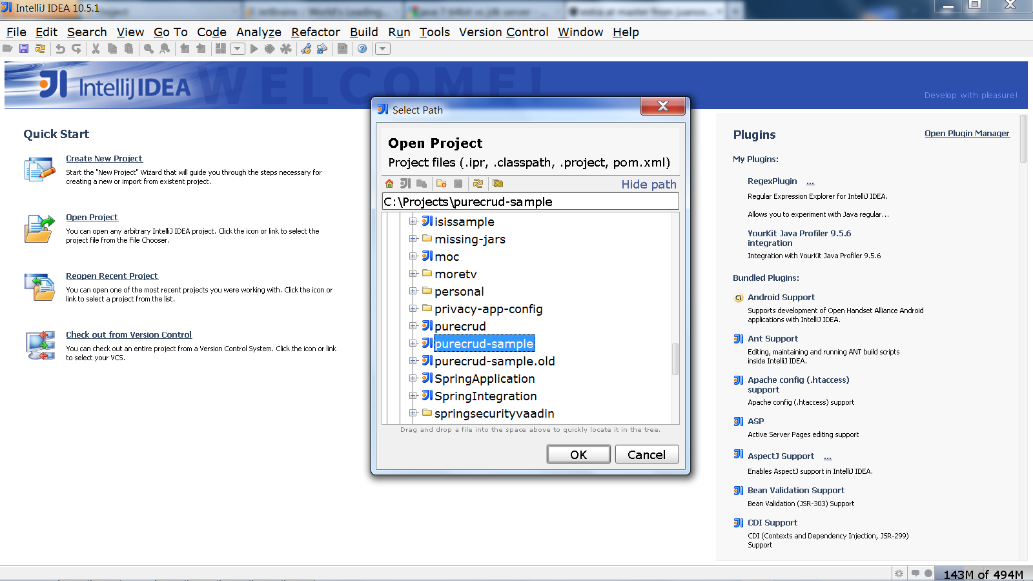

Open the Maven tab on the right. Make sure all profiles are checked. Try running **clean** and then **install** from Intellij.

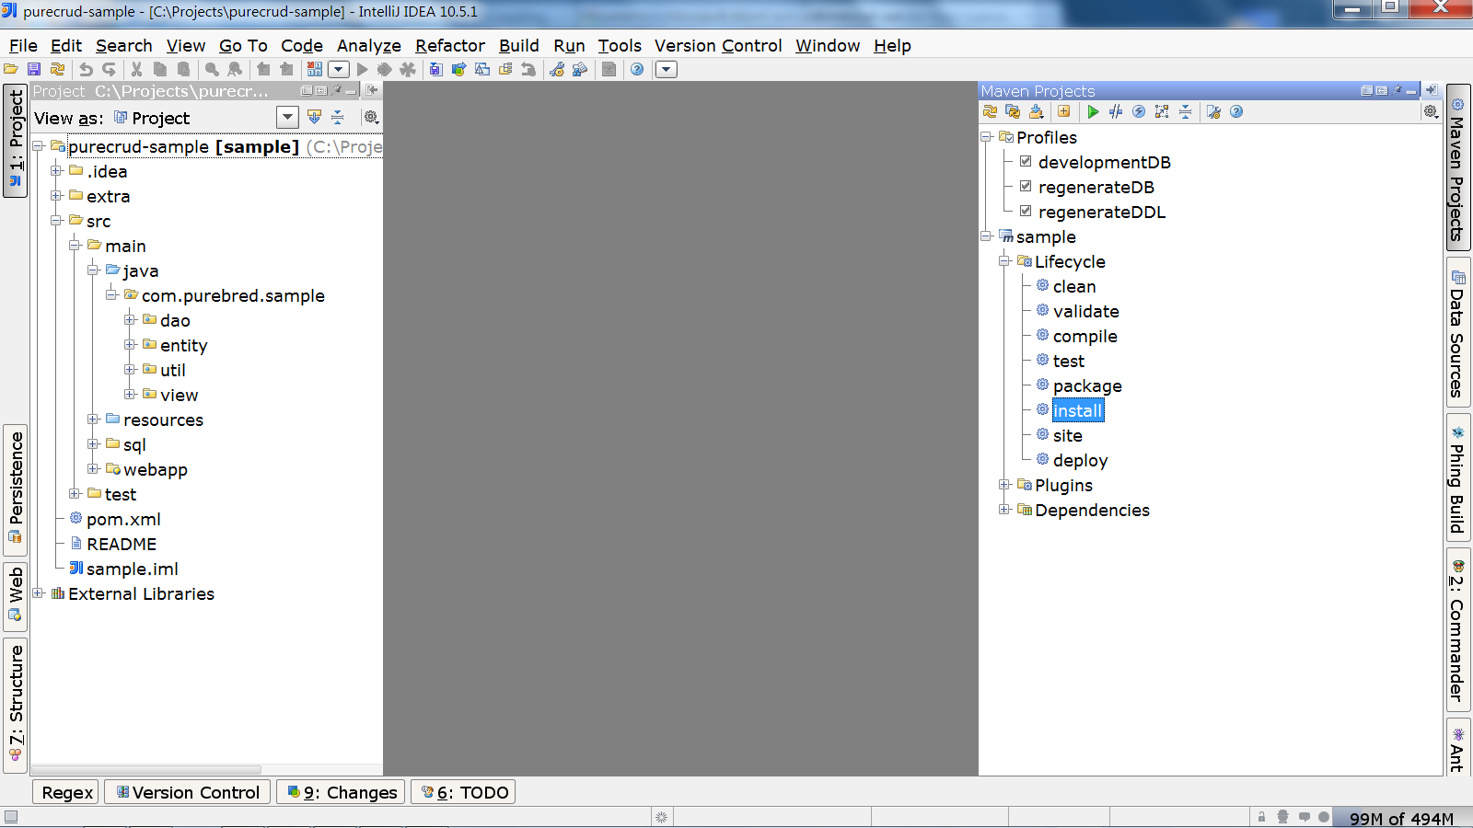

## Launch and Debug from Intellij

1. Launch Jetty from Intellij under debug mode. Set break points.
2. Access application URL: <http://localhost:7001/sample/app>

# Install SQuirreL SQL Client

SQuirreL SQL is a free tool that is capable of reading H2 database files, which PureCRUD uses as the lightweight database for development. This is useful for debugging.

1. Download and following instructions here: <http://www.squirrelsql.org/#installation>
2. Configure database connection like so:

